Python:

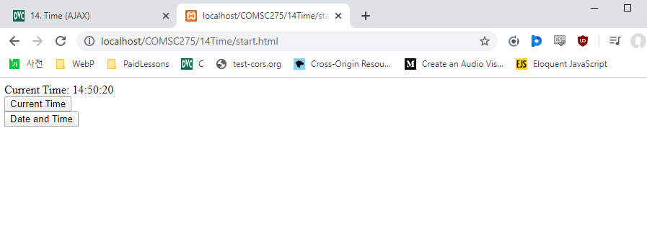

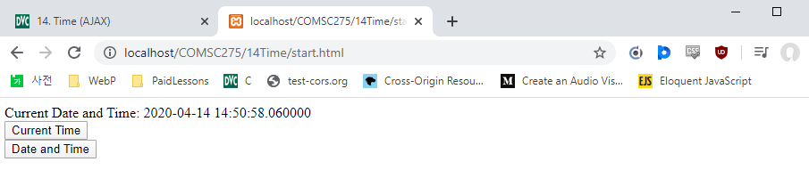

Start.html

<!DOCTYPE html>  
<html>  
<head>  
<script>  
var myReq=new XMLHttpRequest();  
  
function timeReq() {  
 //alert ("timeReq");  
 myReq.onreadystatechange=timeRes;  
  
 var theUrl="time.py?";  
  
 var myRand = parseInt(Math.random()*999999999999999);  
  
 theUrl = theUrl +"rand="+myRand;  
  
 myReq.open('GET',theUrl,true);  
 //alert ("mytime2");  
 myReq.send(null);  
 //alert ("mytime3");  
}  
function dateTimeReq() {  
 //alert ("dateTimeReq");  
 myReq.onreadystatechange=timeRes;  
  
 var theUrl="dateTime.py?";  
  
 var myRand = parseInt(Math.random()*999999999999999);  
  
 theUrl = theUrl +"rand="+myRand;  
  
 myReq.open('GET',theUrl,true);  
  
 myReq.send(null)  
}  
function timeRes(){  
 //alert ("timeRes");  
 if(myReq.readyState==4 && myReq.status==200){  
  
 //alert("timeRes1");  
  
 if (myReq.responseXML==null && myReq.responseText==null){  
  
 //alert("null");  
  
 return;  
  
 }  
  
 else if (myReq.responseXML==null && myReq.responseText!=null){  
  
 //alert("responseXML null");  
 var resValue=myReq.responseText;  
  
 //alert(resValue);  
  
 }  
  
 else{  
 // alert("responseXML");  
 var xmldoc = myReq.responseXML;  
  
 var dateTime=xmldoc.getElementsByTagName("dateTime")[0];  
  
 var resValue=dateTime.childNodes[0].nodeValue;  
  
 alert(resValue);  
  
 }  
 var span=document.getElementsByTagName("span")[0];  
  
 span.innerHTML=resValue;  
  
 }  
}  
</script>  
</head>  
  
<body>  
<span></span><br>  
<button onclick="timeReq()">Current Time</button><br>  
<button onclick="dateTimeReq()">Date and Time</button><br>  
</body>  
  
</html>

Time.py

#!/Python27/Python  
  
from datetime import datetime  
  
dateTime = datetime.now()  
  
time = dateTime.time().strftime('%H:%M:%S')  
  
print("Content-type: 'text/txt' \n\n")  
print("Current Time: ")  
print(time)

dateTime.py

#! /Python27/Python  
  
from datetime import datetime  
  
dateTime = datetime.now()  
  
print("Content-type: 'text/xml' \n\n")  
  
print("<?xml version='1.0' ?>")  
  
print("Current Date and Time: ")  
  
print("<dateTime>")  
  
print(dateTime)  
  
print("</dateTime>")

PHP:

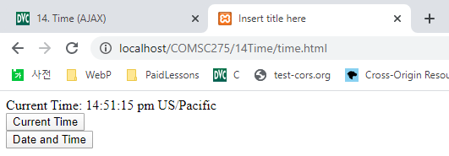

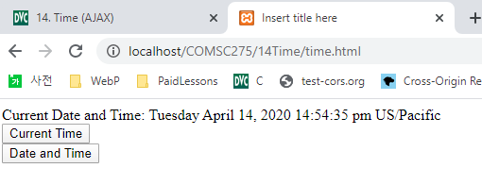

Time.html

<html>

<head>

<meta http-equiv=*"Content-Type"* content=*"text/html; charset=ISO-8859-1"*>

<title>Insert title here</title>

</head>

<body><script>

**var** myReq=**new** XMLHttpRequest();

**function** timeReq(){

//alert("timeReq");

myReq.onreadystatechange=timeRes;

**var** theUrl="time.php?";

**var** myRand = parseInt(Math.random()*999999999999999);

theUrl = theUrl +"rand="+myRand;

myReq.open('GET',theUrl,**true**);

myReq.send(**null**);

}

**function** dateTimeReq(){

//alert("dateTimeReq");

myReq.onreadystatechange=timeRes;

**var** theUrl="dateTime.php?";

**var** myRand = parseInt(Math.random()*999999999999999);

theUrl = theUrl +"rand="+myRand;

myReq.open('GET',theUrl,**true**);

myReq.send(**null**);

}

**function** timeRes(){

**if**(myReq.readyState==4 && myReq.status==200){

//alert("timeRes");

**if** (myReq.responseXML==**null** && myReq.responseText==**null**){

//alert("null");

**return**;

}

**else** **if** (myReq.responseXML==**null** && myReq.responseText!=**null**){

**var** resValue=myReq.responseText;

//alert(resValue);

}

**else**{

**var** xmldoc = myReq.responseXML;

**var** dateTime=xmldoc.getElementsByTagName("dateTime")[0];

**var** resValue=dateTime.childNodes[0].nodeValue;

//alert(resValue);

}

**var** span=document.getElementsByTagName("span")[0];

span.innerHTML=resValue;

}

}

</script>

<span></span><br>

<button onclick="timeReq()">Current Time</button><br>

<button onclick="dateTimeReq()">Date and Time</button><br>

<br><br><br>

</body>

</html>

time.php

<?php

*date_default_timezone_set*('US/Pacific');

$time=*date*('H:i:s a e');

**print**("Current Time: ");

**print** $time;

?>

dateTime.php

<?php

*date_default_timezone_set*('US/Pacific');

$dateTime=*date*('l F j, Y H:i:s a e');

*header*('Content-type: text/xml');

**print** "<?xml version=\"1.0\" ?>";

**print** "Current Date and Time: <dateTime>$dateTime</dateTime>";

?>